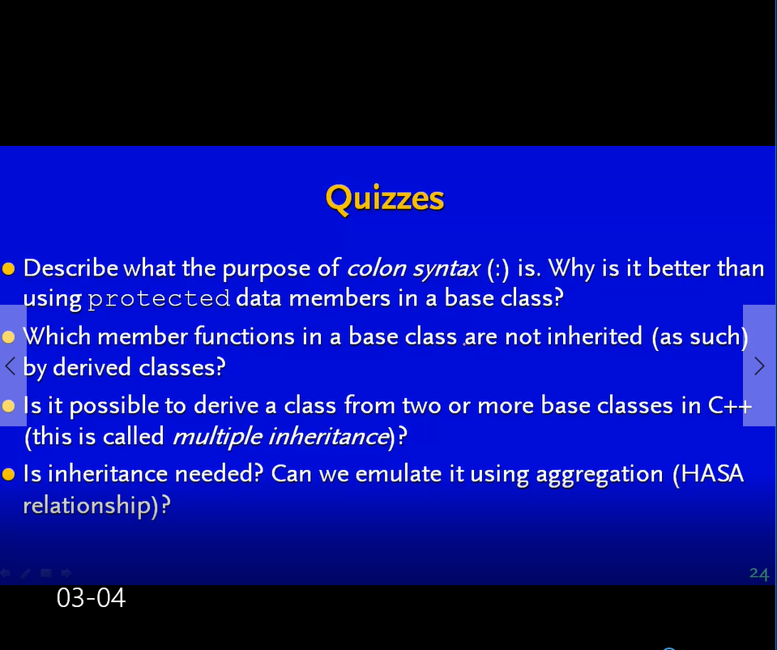

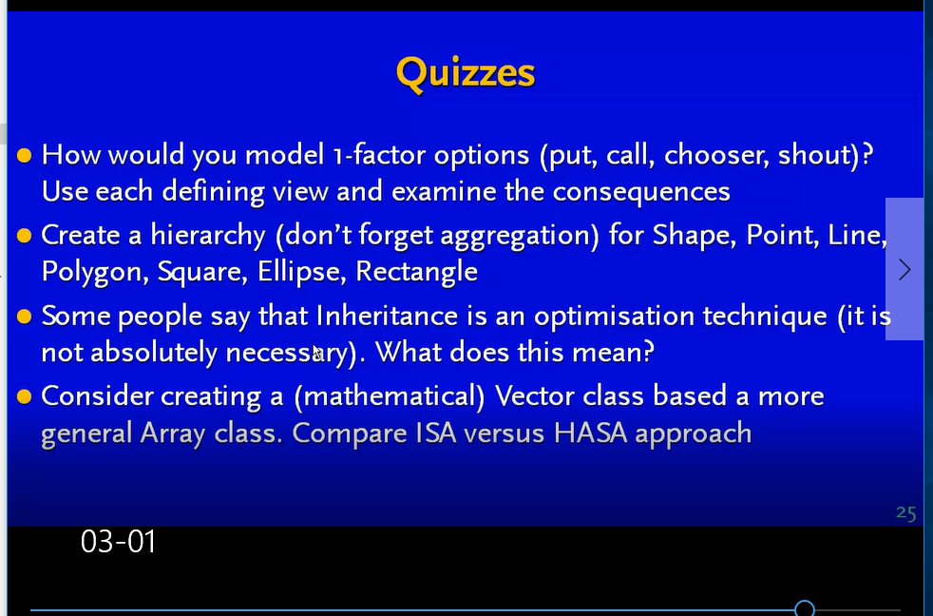

Calling virtual functions is about 10 x slower/less efficient than calling a non-virtual function. reason – include an extra pointer to a method in a virtual function table at runtime– so it has to be searched for at runtime

Consider (1) parametric (compile-time) polymorphism (via template classes) instead of (2) subtype (run-time) polymorphism

1 : template classes; much more efficient but less flexible

2.: provides flexibility at possible speed costs; advantage you can switch at runtime between different pointers between different derived classes.

Problems in the past I need to learn from:

People used too much IS-A hierarchies (WHICH IS INHERITANCE) vs Has-A (WHICH IS COMPOSITION)

Note: colon syntax can improve performance of constructors

All other things equal, your code will run faster if you use initialization lists rather than assignment.

